STOCK PILOT ERD

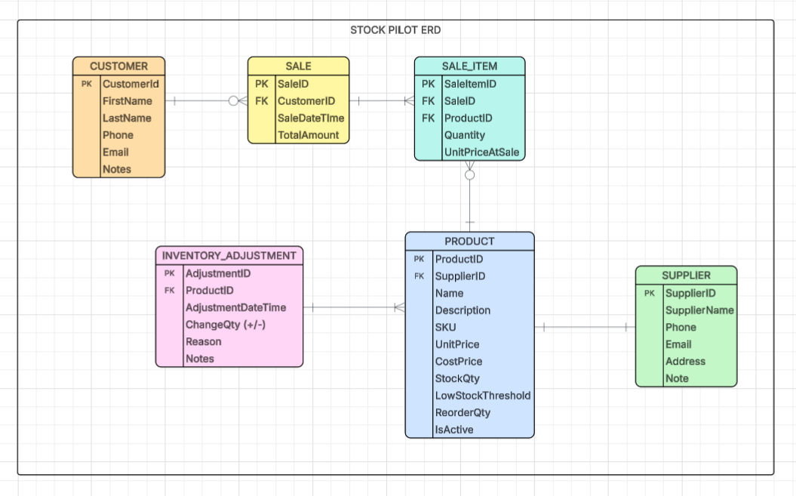

https://github.com/sangampraz/SPU_CSC3220_W26_Team_Azur

